Managing Money for Young Adults with Disabilities

This resource is for use outside the classroom and may be used with the support of family members and caregivers.

This resource is designed to equip young adults with disabilities with the knowledge and skills to manage money and engage independently and inclusively in the community.

This resource is formatted for easy reading. It includes strategies, activities, links to resources on financial literacy, community connections, and a glossary of financial terms.

Icons are attributed to Creative Commons and The Noun Project (2024)
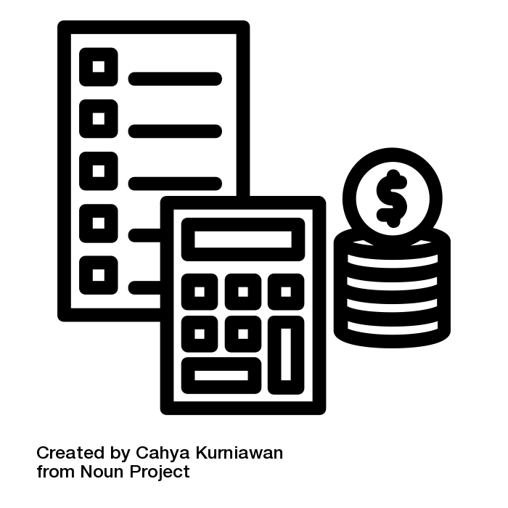 | Definition  Managing Money is how you handle your finances, from budgeting to investing, saving, and setting goals.
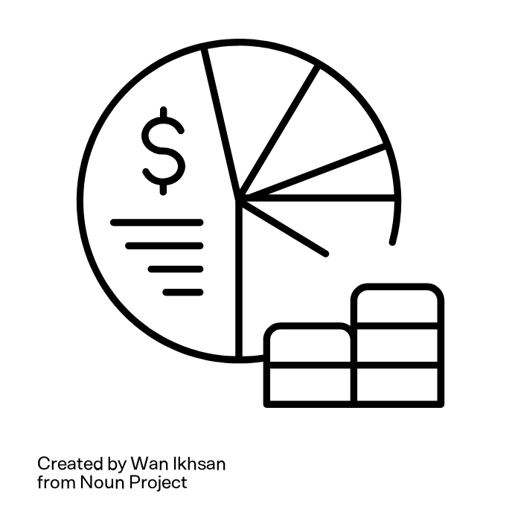 | Example  Budgeting is a plan that outlines the money you expect to earn or receive (income) and how you save it or spend it (expenses).
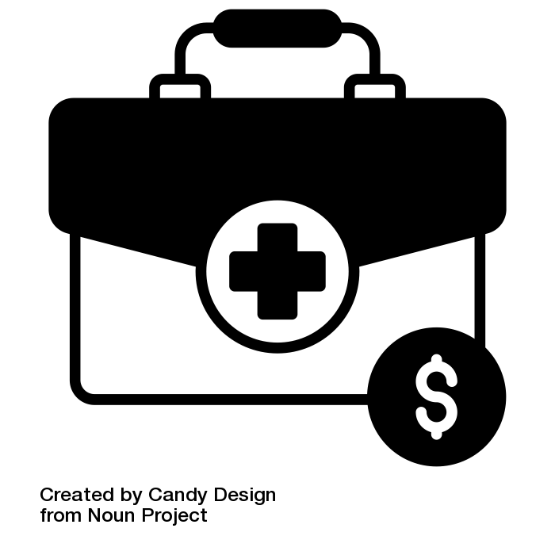 | Example  An emergency fund is a cash reserve for unplanned expenses or financial emergencies, such as a medical bill or income loss.
 | Summary  Managing money involves financial knowledge and decision-making skills. Being informed about budgeting, setting financial goals, and making wise purchasing decisions is essential.

 | Strategy  The 50-30-20 rule of budgeting states that you should spend 50 percent of your income on needs, 30 percent on wants, and 20 percent on savings.
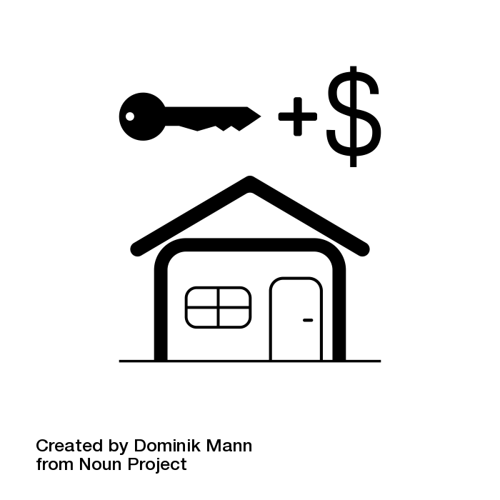 | Example  I will spend 50 percent of my income on rent, groceries, utilities, and transportation.
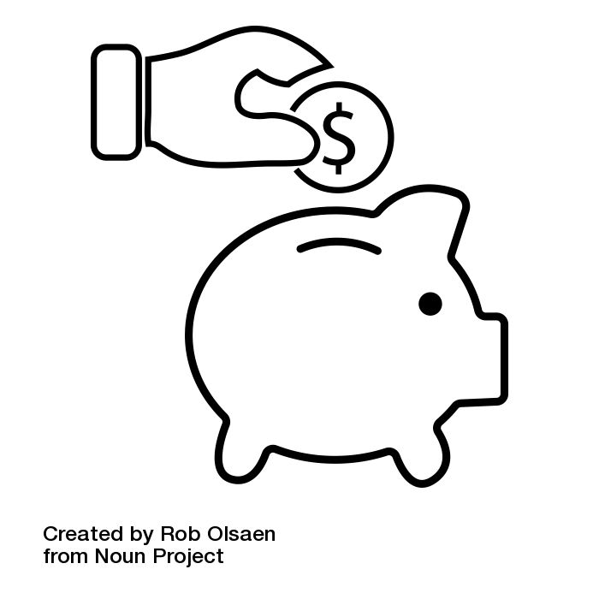 | Example  I will save 20 percent of my income for emergencies, education, and retirement.
 | Activity  Create a budget using the 50-30-20 rule.

Managing Money Resource Links:

YouTube
How to Make a Budget | Money Instructor 4.11 minutes
https://www.youtube.com/watch?v=7Sz3G-rnYZA

Understanding Different Types of Bank Accounts | Beginners Guide | Money Instructor 4.44 minutes

https://www.youtube.com/watch?v=O4-MtfawzAY&list=PL8ILVzj8ksWau2HfeJtFZHXnpOK-rROxQ

What is Investing? | Money Instructor 5.19 minutes

https://www.youtube.com/watch?v=-d0D6SxFKwU

Consumer Financial Protection Bureau
Options for storing your savings
https://www.fhi360.org/wp-content/uploads/drupal/documents/cfpb_building_block_activities_options-for-storing-savings_handout.pdf

https://files.consumerfinance.gov/f/documents/cfpb_building_block_activities_storing-my-savings_worksheet.pdf

Including giving in your budget
https://files.consumerfinance.gov/f/documents/cfpb_building_block_activities_including-giving-your-budget_worksheet.pdf

Your Money, Your Goals Focus on People with Disabilities
https://files.consumerfinance.gov/f/documents/cfpb_ymyg_focus-on-people-with-disabilities.pdf

Federal Deposit Insurance Corporation
Money Smart
https://www.fdic.gov/resources/consumers/money-smart/learn-money-smart/index.html

National Disability Institute
Financial Wellness Tools
https://www.nationaldisabilityinstitute.org/downloads/#financial-toolkit

Wells Fargo
Hands-on Banking Money Skills You Need for Life
https://handsonbanking.org/

Community Connections:
The Arc
Financial Planning Guides
https://thearc.org/free-financial-planning-resources-confirmation/?utm_source=cc&utm_medium=email&utm_campaign=cfp

VCU Financial Success Center
https://business.vcu.edu/centers-institutes-and-labs/vcu-financial-success-center/

Glossary Financial Terms:
Consumer Financial Protection Bureau:
https://www.consumerfinance.gov/consumer-tools/educator-tools/youth-financial-education/glossary/

